**FILENET INTEGRATION WITH BPM**

**Intro:**

ECM server is used for performing operations with documents. We already have a default ECM server in BPM Instead of going with the default BPM Document store we are going to use an external Enterprise Content Management server(ECM) for performing operations with documents which is known as FILENET Server.

**How to Start Filenet Server:**

In FileNet Server we will be having **Content Engine(CE)** and **Content Navigator(CN).**

**1.Start CE and CN Dep manager:**

goto C:\IBM\WebSphere\AppServer\profiles and double click on **statManager.bat** file in both FNDmgr & ICNDmgr folders

**2.Start CE and Cn NodeAgents:**

goto C:\IBM\WebSphere\AppServer\profiles and double click on **startNode.bat** file in both FNppSrv & ICNAppSrv folders

**3.Start CE App Profile:**

open cmd--> goto C:\IBM\WebSphere\AppServer\profiles\FNppSrv and type **startServer.bat server1** and enter

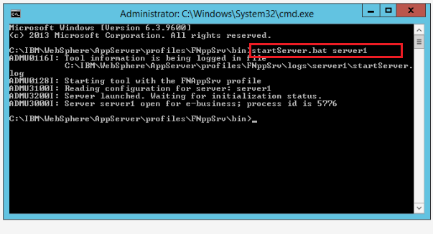

**4.Start CN App profile:**

open cmd--> goto C:\IBM\WebSphere\AppServer\profiles\ICNAppSrv and type **startServer.bat server1** and enter

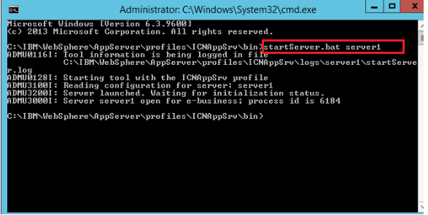

url for **CE** : http://hostname:portnumber/acce (here it is http://fncn:9080/acce/)

url for **CN** : http://hostname:portnumber/navigator (here it is http://fncn:9081/navigator/)

In CE we will have object stores. If we clickon object store in next tab we will get files and folders under **Browse**. In CN we will have Repositories. we will add/configure those object store details of CE in repositories of CN.

**Content Engine Image:**

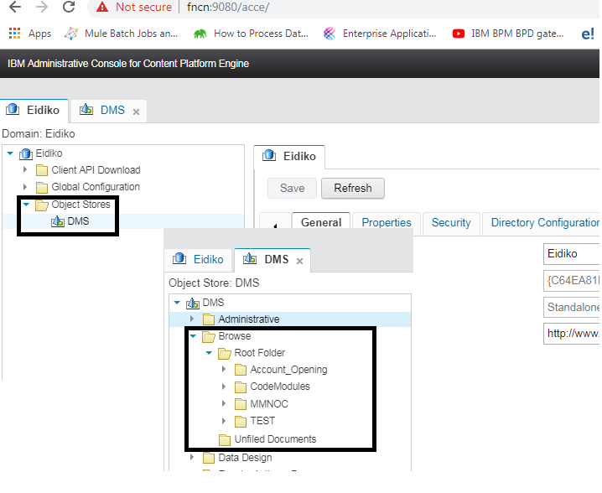

**Content navigator Image:**

The below image shows the configuration of Object Store Details of **CE** in Repository of **CN**

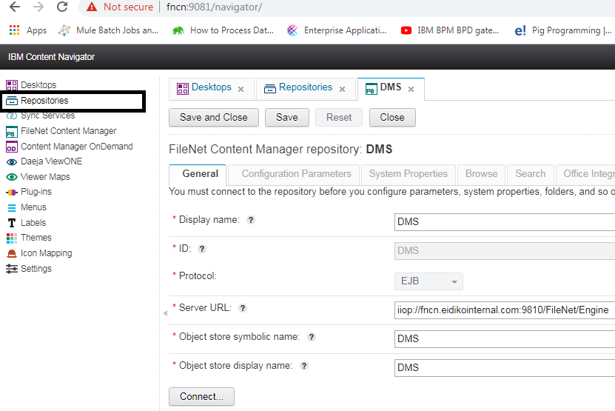**Connecting filenet with BPM:**

Inorder to connect filenet with BPM we need to configure the filenet server details in BPM.

Navigate to Process App Settings => Servers tab => Click on Add =>Enter name and select Enterprise Content Management server.

Under Sever Locations tab fill the filenet server details

**1.Environment Type**: Default/Dev/Testing/staging/Production(In this case select Default)

**2.Hostname:** fncn

**3.Port:**9081

**4.Context path:** fncmis

**5.Repositary:** DMS

**6.UserId:** p8admin

**7.Password:** Sarasu@10 and click on test Connection

**ECM Document Authorization Service:** In 8.5.6 **ECM Document Authorization Service** option is not present so who is bpm user and filenet user has access to files in ECM server. From 8.5.7 this option is added to give security to the files. We have to define authorization service to the users who need to access the files. For this click on new under **ECM Document Authorization Service** and connect start and end points and make "**tw.local.authorized=true**".

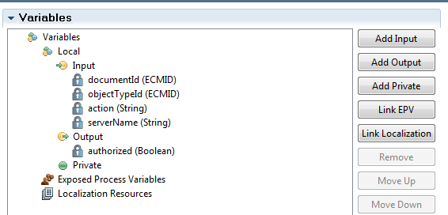

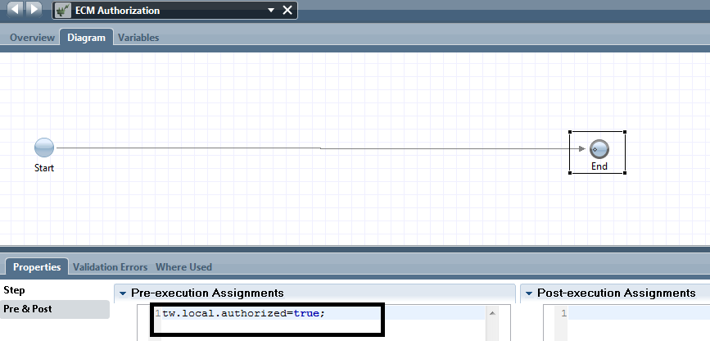

Below is the image which illustrates the server configuration

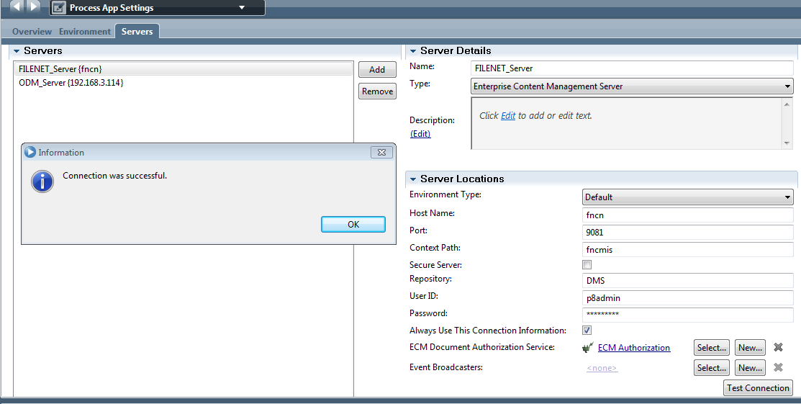

**Example for Searching operation in the filenet Server:**

a. Create one Heritage human service(FileNet HS). In Coach drag one **document List** and **document viewer** into the space.

b. Create a list variable of type ECMDocumentInfo in variables tab.

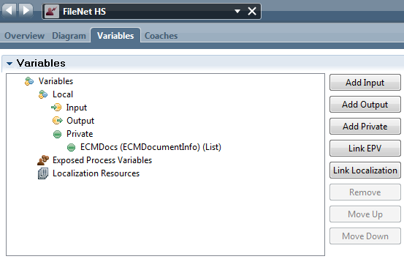

c. Bind the created variable to **document List** as shown below**.**

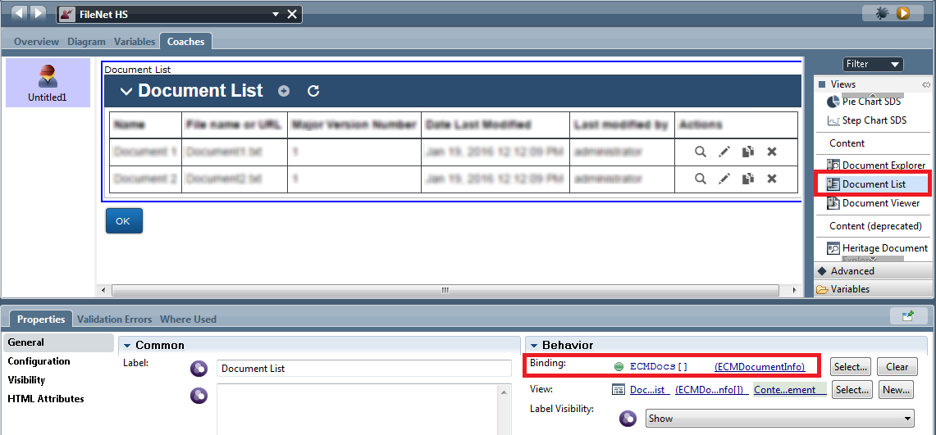

Click on Document Viewer coach view => goto configuration tab => In ECM Document options specify "/" as parent folder path. Click on New under **Search** tab.

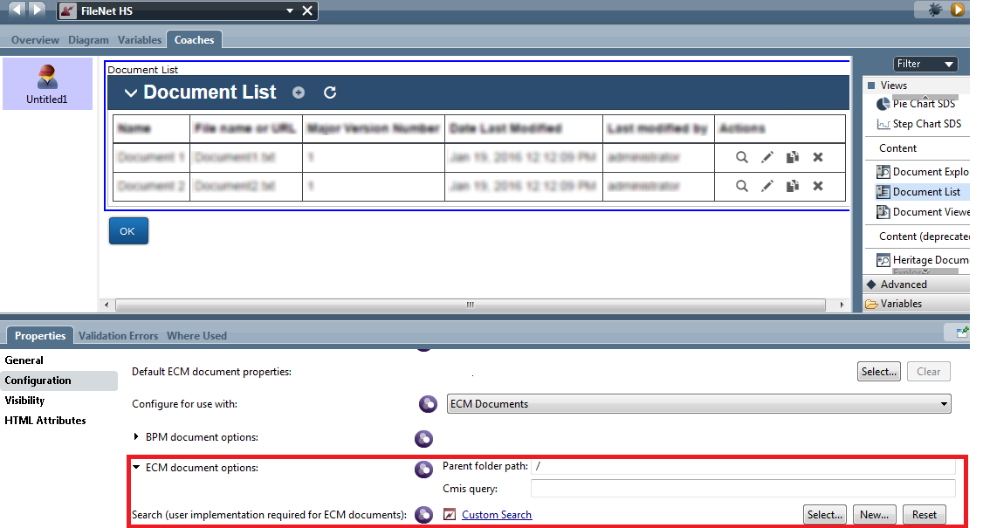

In the ajax Service drag one Content integration component and under implementation tab select **server** as "filenet server" and **operation name** as search.

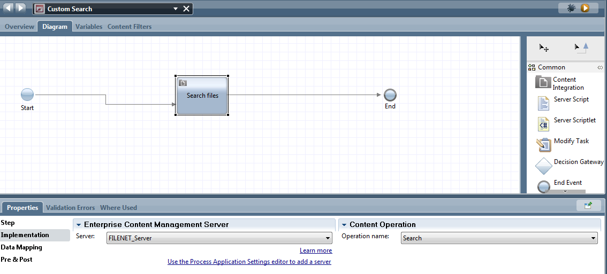

Under data mapping tab create and bind the necessary variables as shown below

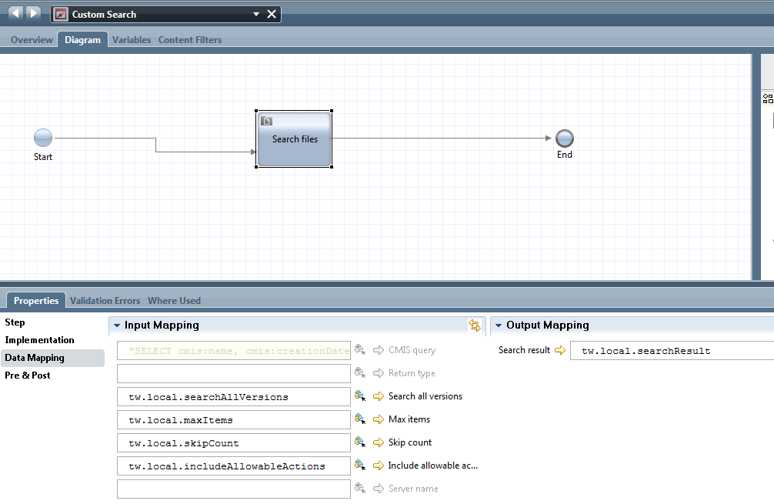

Goto Content filters tab and under object type tab click on select and select document from drop down.

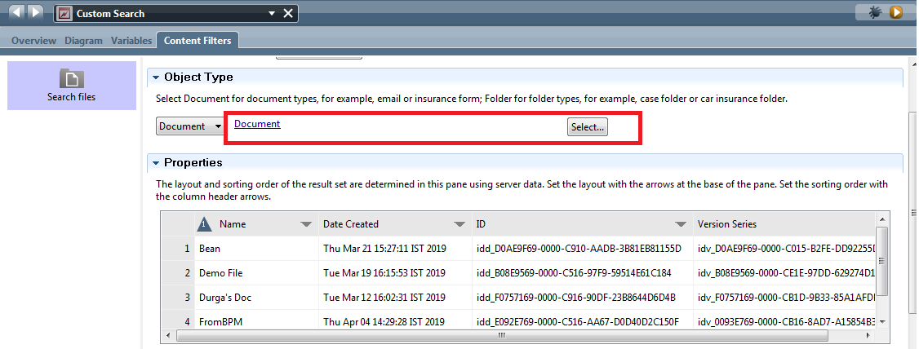

Now run the Heritage Human service(FileNet HS) the documents in the filenet server will be displayed.

